2024 Charlton Youth Soccer
Scholarship Application

Description: Charlton Youth Soccer proudly sponsors a scholarship program for two Charlton high school students (one boy/girl) who are accepted for enrollment at a college/university for 2023/24 school year.

Requirements:
1. Must be a graduating senior who has participated in Charlton Youth Soccer for a minimum of 2 years.
2. Must complete the application below and submit a typed essay on how playing soccer has influenced you in a positive way.

Due Date: Friday, April 26, 2023

Award: Two (2) $250 Scholarships will be presented upon review of all applications.

Name:

Address:

Email:

# of years played at CYS: Grades Participated:

Additional CYS involvement (coaching,ref,volunteer):

High School:

University/College
Attending:

Signature of Applicant:

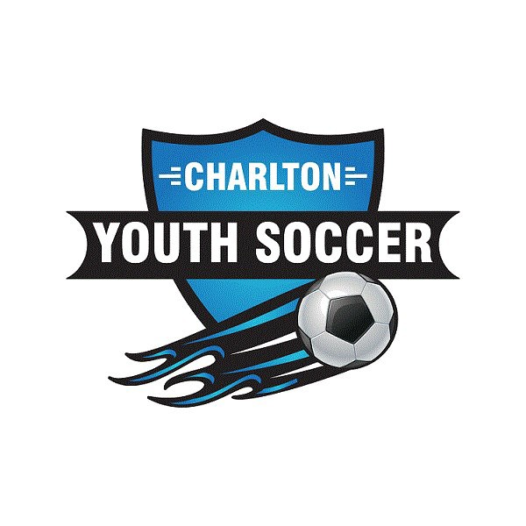
Mail to: Charlton Youth Soccer
P.O. Box 1069
Charlton City, MA 01507

or Email: charltonyouthsoccerinc@gmail.com

